= Git Tutorial=

- git init ---> creates local repository:
git config --list Global(available for all the projects on the system)

- Most important config parameters to be set at global level :
>> git config --global user.name “<username>” ↩
>> git config --global user.email “<email ID>” ↩

- Check local <username> & <email ID>:
>> git config --global user.name ↩
>> git config --global user.email ↩
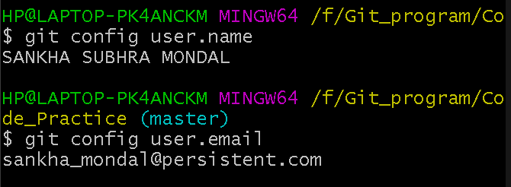

- To Create a file:
>> touch file.extension (e.g: Test.java, index.html)
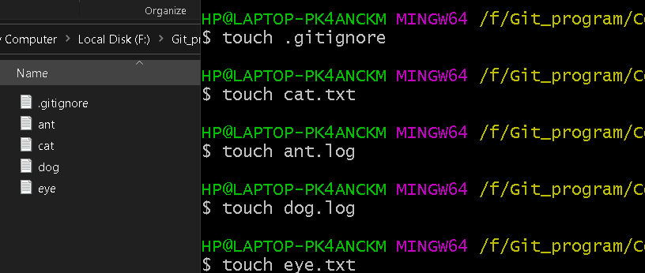

- To Create a file/
>> mkdir NAME-OF-YOUR-NEW-DIRECTORY
- Go back one directory or file:
>> cd ../
- Show into the Folder:
>> ls -a

- Edit local <username> & <email ID>:
>> git config --global --edit ↩
[user]
email = sankha_mondal@persistent.com
name = SANKHA SUBHRA MONDAL
After editing is done to exit press
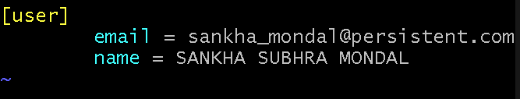
Esc ▶ : ▶ w ▶ q ▶ ↩

- To Check current position:
>> git status ↩
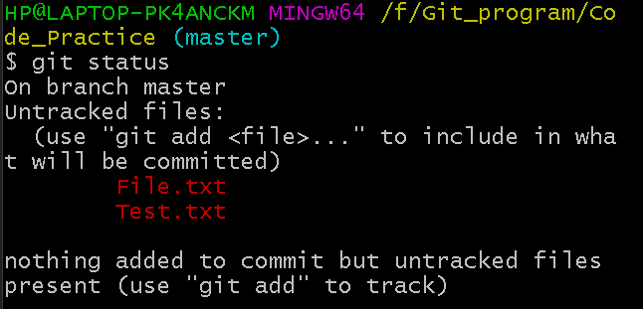

6. Add any <file> to Staging area(SA)/ Caching area/ Index area:
>> git add <file> ↩
Automatically added to Staging area
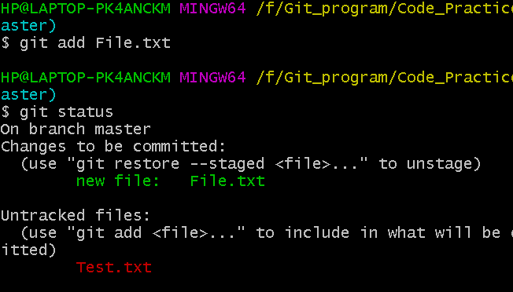
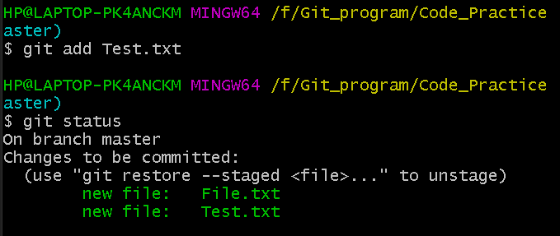
- Track History:
>> git status -s

Some of the status flags are
?? - untracked Files which Git does not know how to handle
A - Added to the staging area
M - Modified
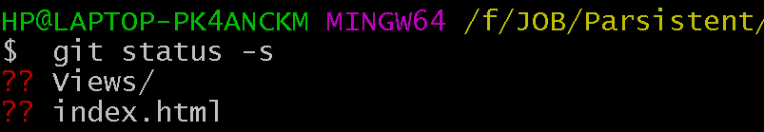

- Add ALL <file> to Staging area(SA)/ Caching area/ Index area:
>> git add . ↩ or git add * ↩
Automatically ALL files added to Staging area

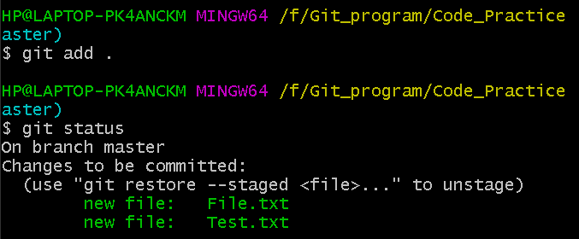
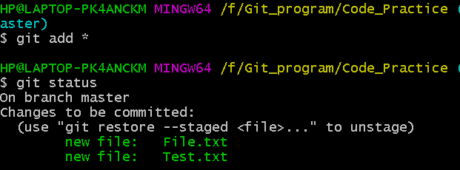

- To discard changes in Working Directory(WD) before Staging:
>> git restore <file> ↩


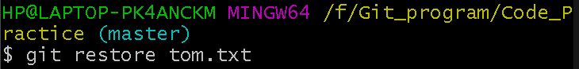


- Remove <file> from Staging area(SA)/ Caching area/ Index area to Unstage:
git rm --cached <file> ↩ or git restore --staged <file> ↩
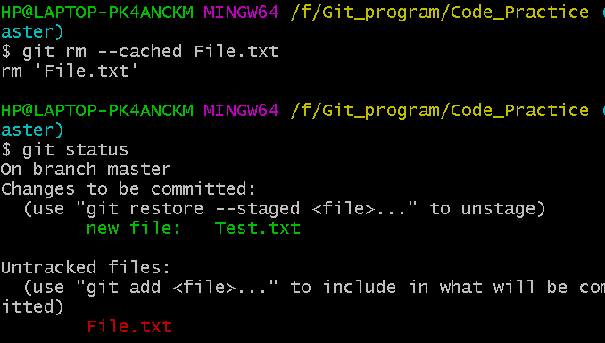
rm 'File.txt' i.e remove the file from SA or make it untracked.

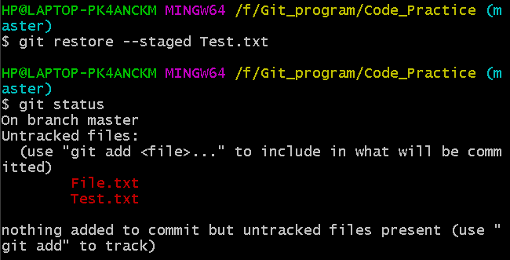

- What is the command to add all files and changes of the current folder to the staging environment of the Git repository?
>> git add --all

- ADD Folders in Parent Folder
>> git add parent_folder/

- Commit(save) the change to Local Reposatory:
>> git commit -m "valid-msg" ↩
e.g : git commit -m "File committed successfully"

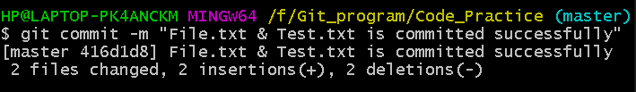

- To add <file> to Staging area and Commit(save) the change
to Local Repository TOGETHER (git add + git commit):
>> git commit -a -m "msg" ↩ or git commit --am “msg” ↩
Note: Don’t use this at the very first time. Use it when the file is
already being tracked.

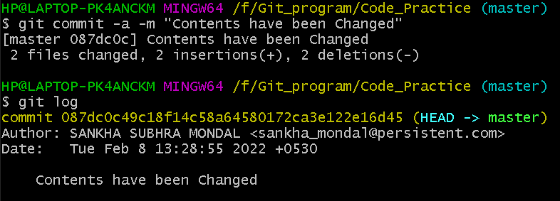

- updates the commit msg for latest commit:
>> git commit --amend -m "msg"

- To Check the version History of Project :
>> git log ↩
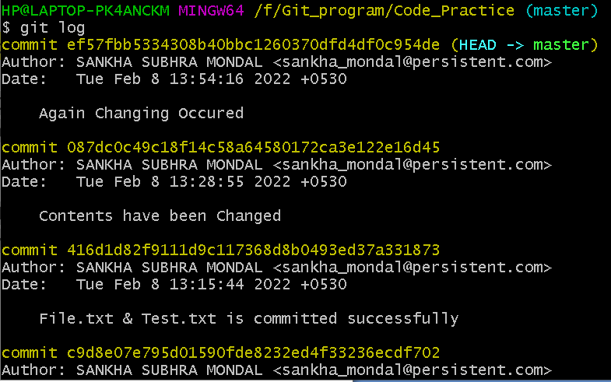

>> git log --oneline ↩ to see only 7 SHA commit
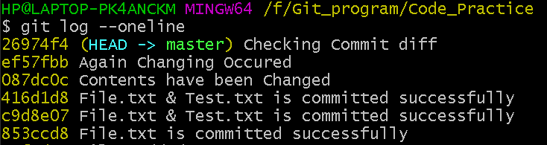

>> git log --oneline -3 ↩ to see only latest 3 commit
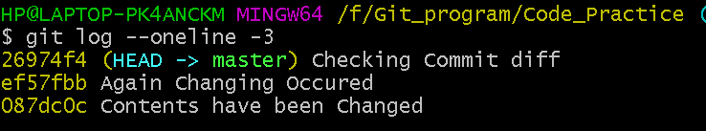

>> git log -p ↩ changes done for every commit (fNew Vs fOld)
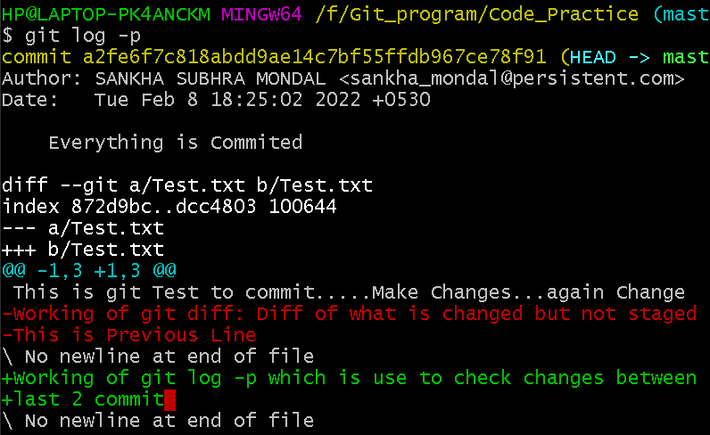

>> git log -p -2 ↩ changes done for latest 2 commit.
>> git log --grep="Initial" ↩ Commit done by Specific words
>> git log --author="authorname" ↩ Commit done by Specific
person
>> git log --since = ”07/30/2021” ↩ Commit done by date
>> git log --until = “07/30/2021” ↩ Commit done by date

- To get DIFFERENCE between Stages(WD, SA, Local Repo) of file:
- Diff of what is changed but not staged yet
>> git diff difference between WD and SA

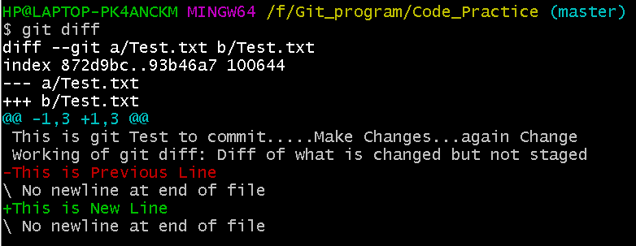

- Diff of what is staged but not yet committed
>> git diff HEAD difference between WD and LR (OR)
>> git diff --staged difference between WD and LR

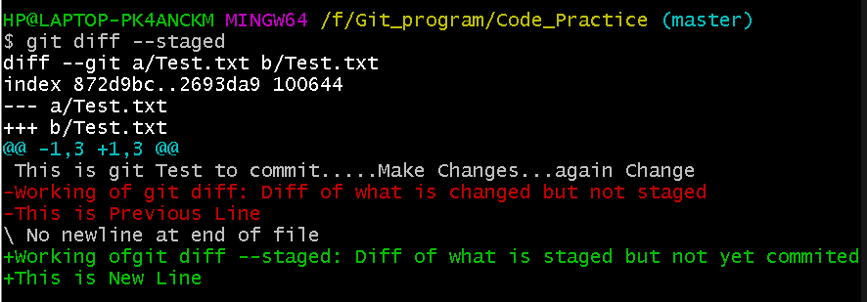

Case 1: Change in Working Directory(WD) :
Command | WD | SA | LR | Result
git diff ↩ | Change1 | 0 | 0 | Change1
git diff HEAD ↩ | Change1 | 0 | 0 | Change1

Case 2: Change in Staging area (SA) :
Command | WD | SA | LR | Result
git diff ↩ | Change1 | Change1 | 0 | No Output
git diff HEAD ↩ | Change1 | Change1 | 0 | Change1
git diff HEAD ↩ | Change1 | Change2 |  | Change1 & Change2

Case 3: Put change to SA and change in WD again :
Command | WD | SA | LR | Result
git diff ↩ | Change1+Change2 | Change1 | 0 | Change2
git diff HEAD ↩ | Change1+Change2 | Change1 | 0 | Change1 & Change2
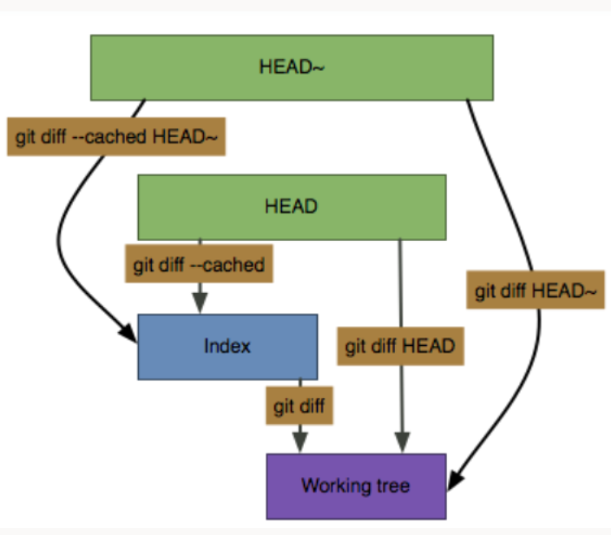

- Create File:
>> touch file

- Rename File which is [staged earlier] :
>> git mv <oldFile> < newFile>
Note: now it’s in staging area
To Un-stage, do git restore --staged <file>
- Restoring/Undoing local/to un-stage changes :
- Restore the changes in Staging area(SA) from LR
git restore --staged <file> ↩
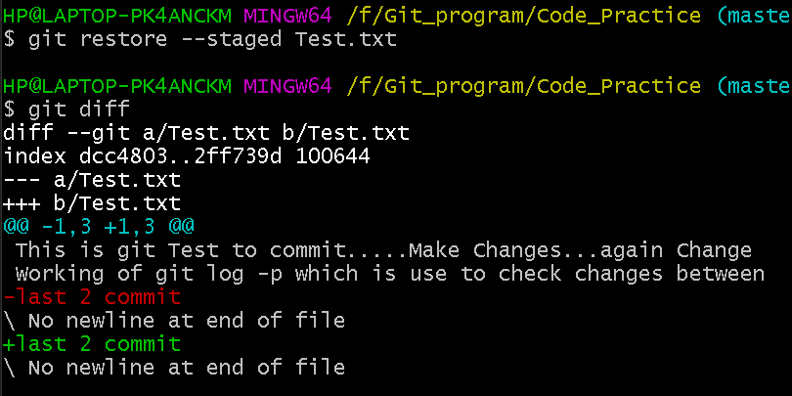

- Restore changes in WD from LR
git restore <file> ↩
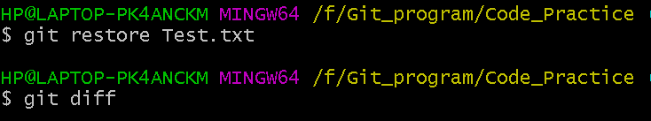

- Undoing of committed changes :
- Safe way
>> git revert <SHA> ↩ i.e to ignore wrong commit, treat
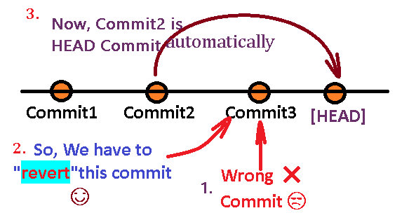
(before past)commit as HEAD

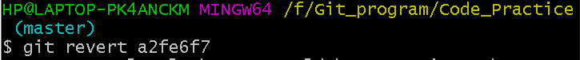

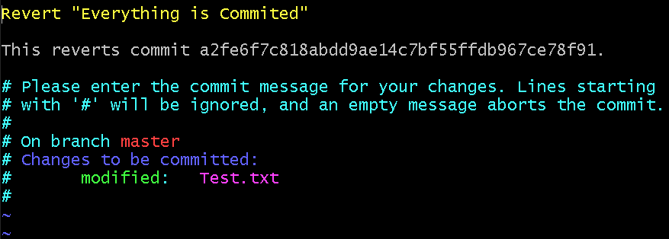

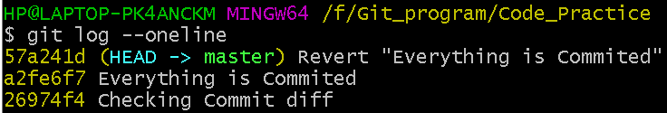

- UnSafe way
i) git reset --hard <SHA> ↩ To move HEAD pointer, but previous commit is deleted permanently.
Options:
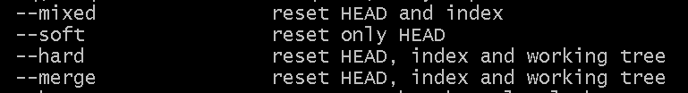

Previous :
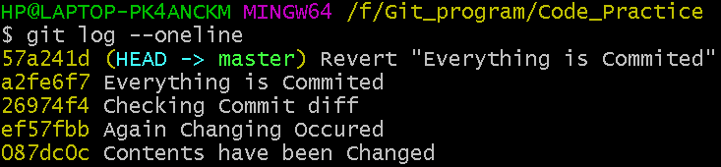

Performing Hard Reset, to move HEAD pointer from (57a241d) to (a2fe6f7)
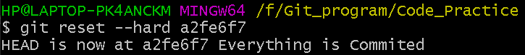

HEAD Pointer changed it’s position (57a241d) to (a2fe6f7)
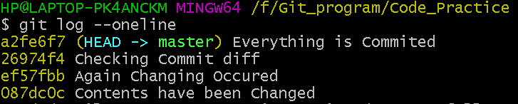

ii) git reset --hard~3 ↩ Permanently delete new 3 commit & HEAD pointer is pointing to 4th Commit.
Previous :
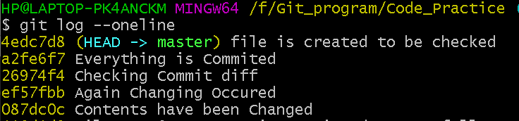

Performing Hard Reset~3, to DELETE first 3 Commit i.e (4edc7d8),( a2fe6f7), .. .
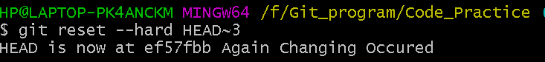

HEAD Pointer changed it’s position to 4th Commit :
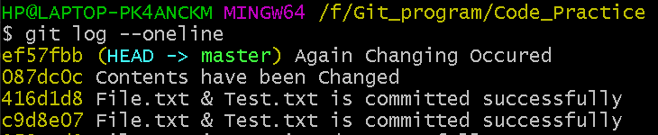

- Delete Files :
- Untracked Files:
>> git clear -n ↩ (gives Warning first then)
>> git clear -f ↩ (Firstly Delete)

- Delete <file> from Folder which is [committed earlier] from Working Directory :
>> git rm <filename> [it is staged automatically]
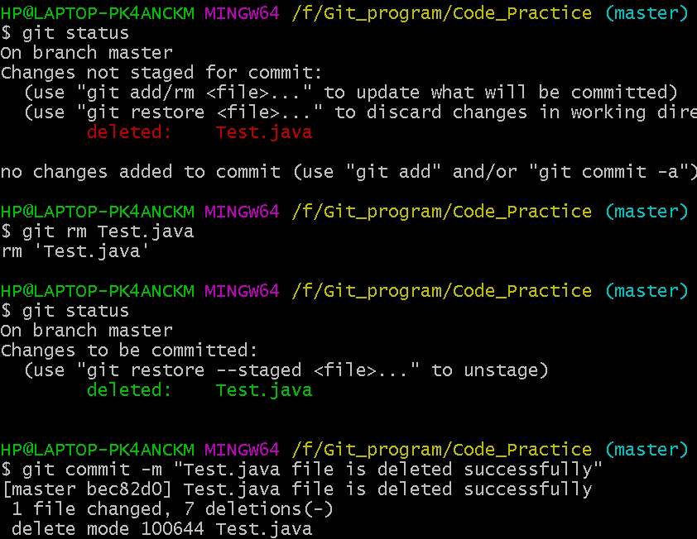

Branch
- Check how many Branch are there..?
>> git branch
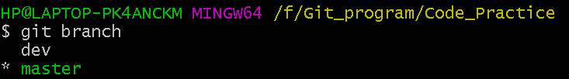

- Creating a NEW Branch :
>> git branch branchName ↩
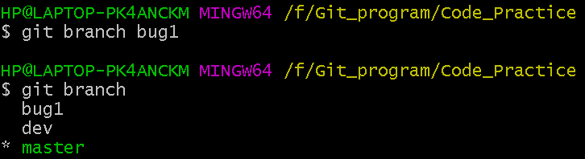

- Switch to Another Branch :
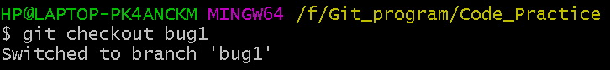
>> git checkout branchName

- To Check current position:
>> git status
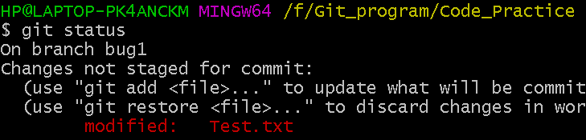

- To Staged & Commit the File Together :
>> git commit –am “message”
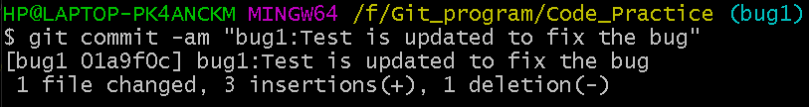

- To Check History :
>> git log --oneline
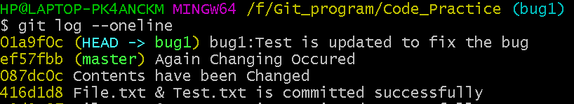

- To MARGE Child Branch with Parent Branch :
- We have to move the HEAD pointer to Parent Branch.
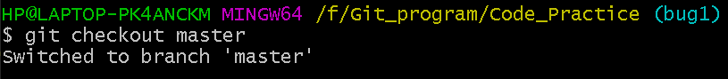

- Verify the Parent Branch is in Remote Repo Condition.
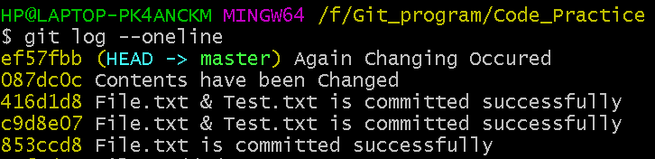
- Now MERGE with Parent Branch.
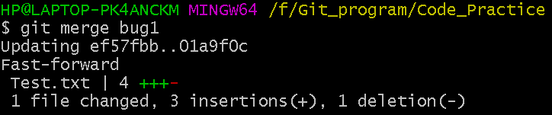

- To Check History AGAIN & see successfully Merged:
>> git log --oneline
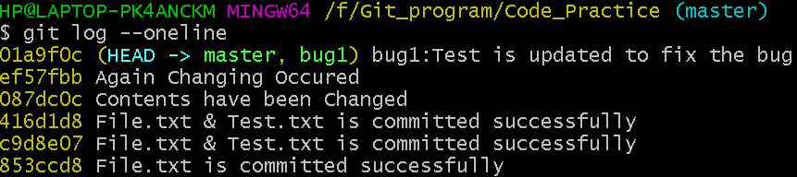

- Delete the Branch after Merging : (GOOD Practice)
>> git branch -d branchName
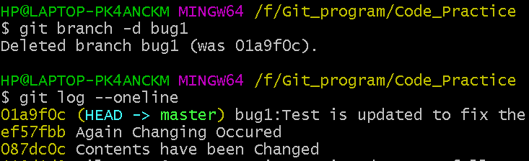

- Delete a Branch Forcefully without Merged
>> git branch -D branchName (Use Capital D)
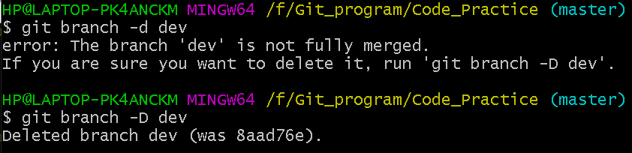

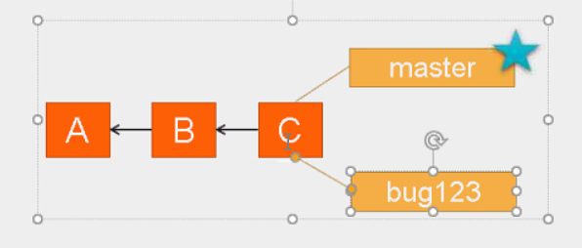

- Create a Branch + Switch in it :
>> git checkout -b branchName
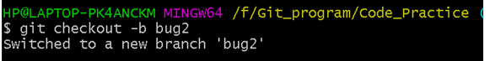

- Recover the deleted branch ‘branchName’ and rename it to ‘newBranchName’
>> git checkout -b branchName <SAH> (THEN)
>> git branch -m branchName newBranchName

- Rename a branch
>> git branch -m <old> <new_branch_name>

- Commit the change using command git commit

- Differences between the current branch and the branch "new-email"
>> git diff new-email

***Push***
git push -u origin master

- Rebase Merge
Q. Consider the following scenario and achieve the same to Rebase:-
-Create new branch ‘idea’ and make a new commit on ‘idea’ branch
- Now checkout to master and make a new commit on master
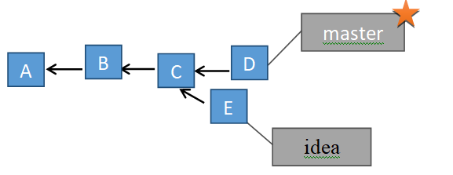

$ git checkout -b idea
Switched to a new branch 'idea'

$ git commit -am "idae:new change added:commit E"
[idea a0bb15a] idae:new change added:commit E
1 file changed, 2 insertions(+)

$ git checkout master
Switched to branch 'master'

$ git commit -am "master:new change added:commit D"
[master 7795d64] master:new change added:commit D
1 file changed, 2 insertions(+)

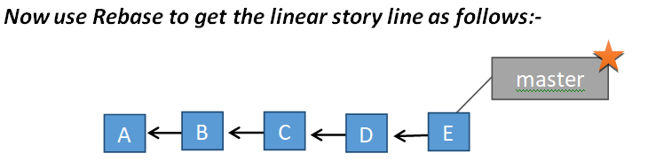

Steps: $ git checkout idea [where idea is branchname]
$ git rebase master
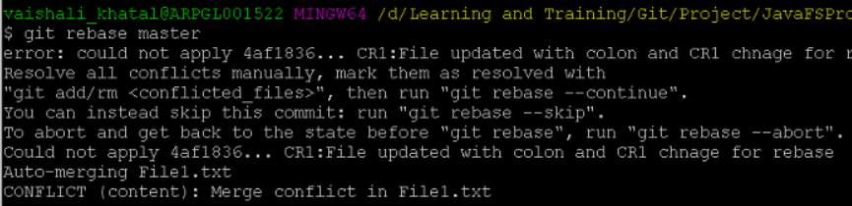

Steps
Git status Open your actual file(<<< ===text=== >>>) and change git add . git status git commit –m <msg> git rebase --continue (and get a pop-up to edit msg…)
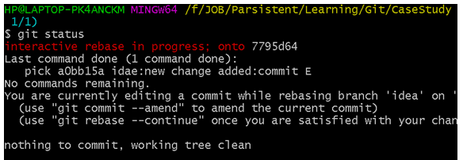
Now you got.. But you have to change
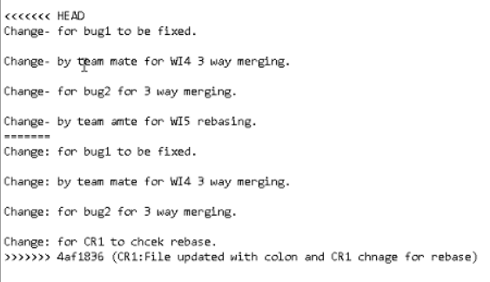

Changed file
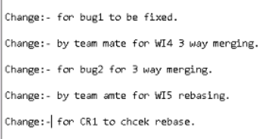
git add .

git status

Git commit –m <msg>

git rebase --continue (and get a pop-up to edit msg…)
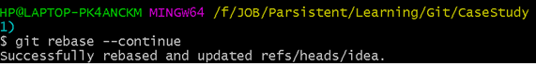
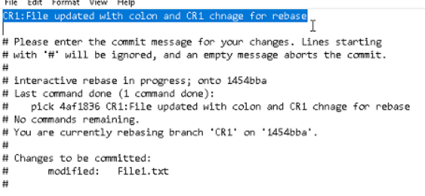
$ git status

$ git log –oneline

$ git checkout master
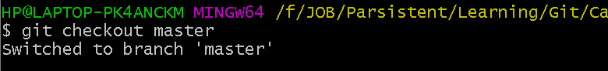

$ git merge idea
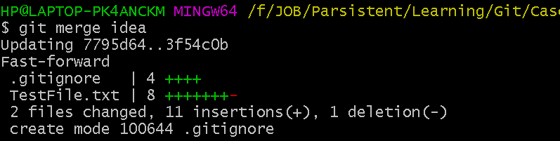

$ git branch -d idea

3 way Merging
`Check Day 2 Video at 2:30 hr

Git Tag
- To give Tag name :
>> git tag tagName <SAH>
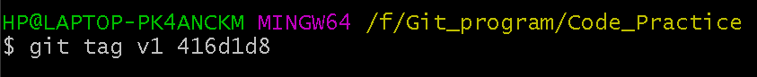

- Tag Check Out:
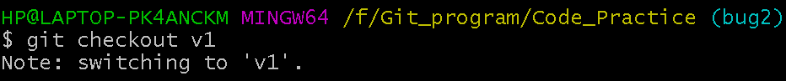

- To check history :
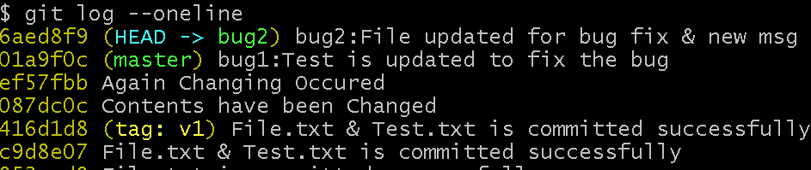

Git – Stash
Git – Stash is very useful. It is needed only when you are working on a task but manager say you have to complete another task immediate-ely. So we have to switch your task from older one.

- To save my older task without commit : (Because you can’t switch to other branch without commit)
>> git stash save
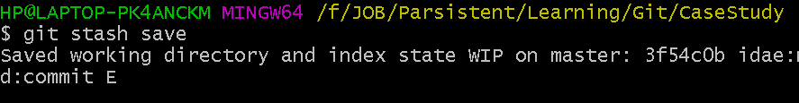
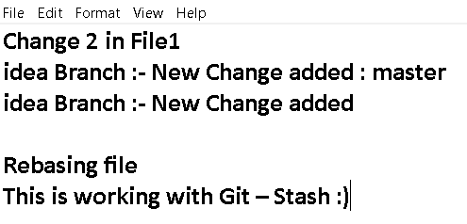
- Now You Can Switch to other Branch :
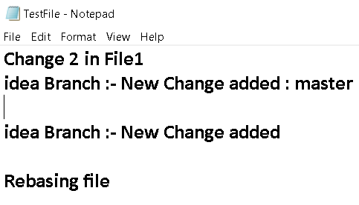
Now perform your new task, if you check the file in which you were previously work the texts are missing because you moved to another branch.

You can do the other task which your manage told to do
After that if you want to go with your own task then follow these steps below:

>> git stash pop (if you are sure you want your previous Edition)
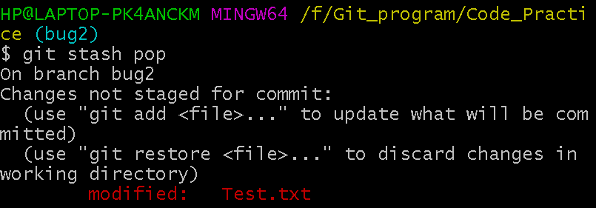

>> git commit –am “Final commit or anything” (To commit own work)
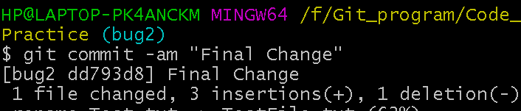

Which is the command to remove everything from the stash?
>> git stash clear

SHA - Secure Hash Algorithm - SHA-1
Fixed length hash = SHA(input data) --> data can be in bits/bytes/GBs/TBs

Properties SHA -
- Deterministic - For same input we always get same output, regardless of
the OS, environment.
- Output should be fixed length.
- Avalanche Effect - For any minor change, entire hash value changes.
- Unique Value - Any 2 inputs should have same hash value

Git Pushing
Step :1
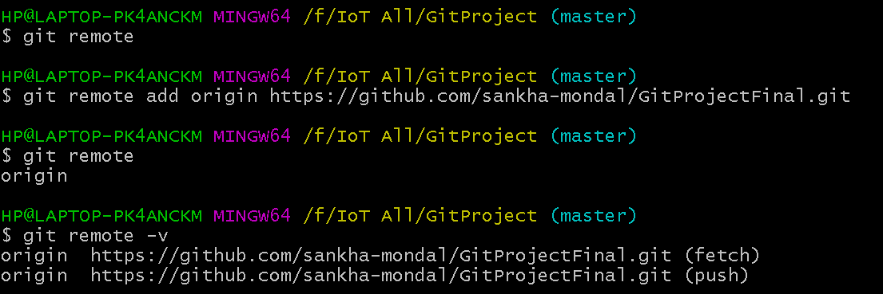
Step : 2 Create Token
Settings Developer Settings Personal access token Generate new token

Step : 3
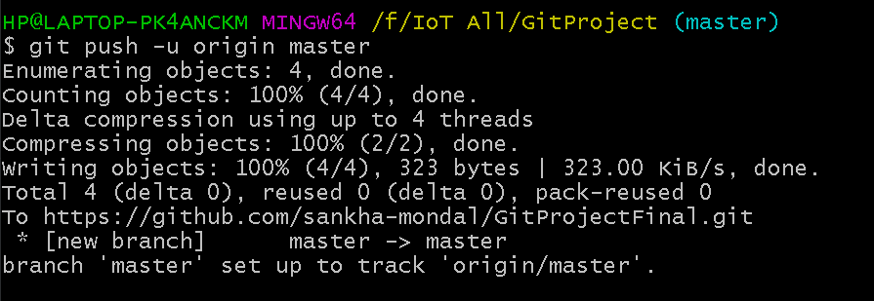

GIT PULL

- To pull total content from local Repository:
>> git pull

Question & Answer
- What is the command to create a new branch named "new-email"?
>> git branch new-email

- Which one of these statements about a merge involving a merge commit is true?
>> Git places the result of the merge into a new commit.

- What does the git merge option -s abbreviate?
>> --strategy

- What is the option, when moving to a branch, to create the branch it if it does not exist?
>> -b

- What is the command to move to the branch named "new-email"?
>> git checkout new-email

- What is a request to merge your branch into another branch called?
>> Pull request

- When should you avoid rebasing a branch?
>> If you have shared the branch

- In Git, a branch is?
>> A separate version of the main repository

- What is the command to merge the current branch with the branch "new-email"?
>> git merge new-email

- What is the command to show the differences between the current branch and the branch "new-email"?
>> git diff new-email

- Which of these two statements makes git use the file from the conflicting commit you are merging from?
>> git checkout --theirs index.html

- Find the command which is used to rename a branch
>> git branch -m old_branch_name new_branch_name

- Which is correct about git checkout -b test_branch
>> Creates a new branch test_branch and switches to the test_branch

- True or False?.git branch -D branch_name is used to delete the branch
>> True

- Which is incorrect regarding branches.
>> Branches cannot be merged.

- If --list is given, or if there are no non-option arguments, existing branches are listed
>> True

- True or false? It is not possible to delete a branch once created
>> False

- Which is true regarding Git fails to start the merge?
>> All of the listed options

- git config --global merge.tool is used to set merge tool on project level
>> True

- Which is true regarding git diff.
>> git diff is a multi-use Git command that when executed runs a diff function on Git data sources.

- .git pull runs git fetch in the background and then git merge to merge the retrieved branch heads into current branch.
>> True

- Which one of the following is not part of the data structure of a Git repository?
>> Body element

- Consider if you as an individual working in an organization wants to see information regarding the commit or you Need to see who else checked in specific files, in that case, what command you would use to sort it out.
>> gitk

- What's the opposite of git clone, instead of downloading your code from GitHub, uploads your changes and code back to GitHub?
>> git push

- GitHub is the same as Git.
>> FALSE

- Which of these terms best describes GitHub?
>> Web-Based Repository Hosting Service

- How do you create a copy of a lab under your own GitHub account so that you can solve the lab?
>> Forking it via the GitHub interface

- What's the git command that downloads your repository from GitHub to your computer?
>> git clone

Git Work Flow 1:
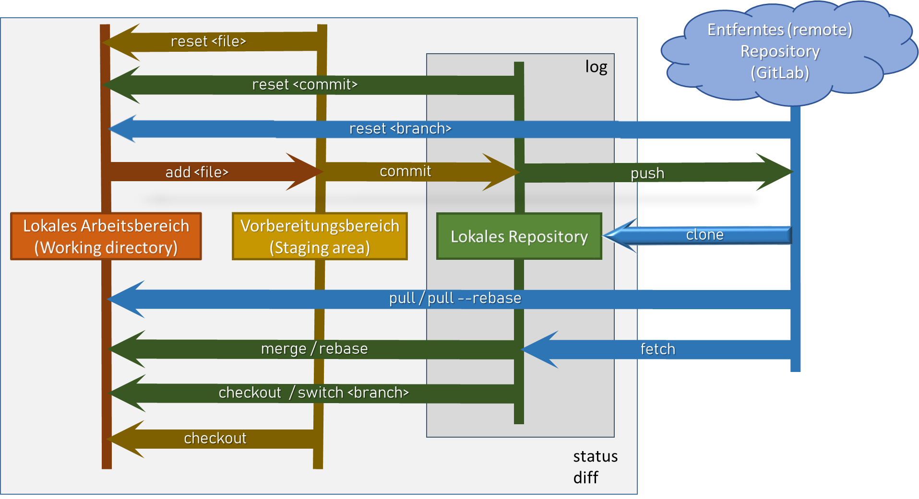

Git Work Flow 2:

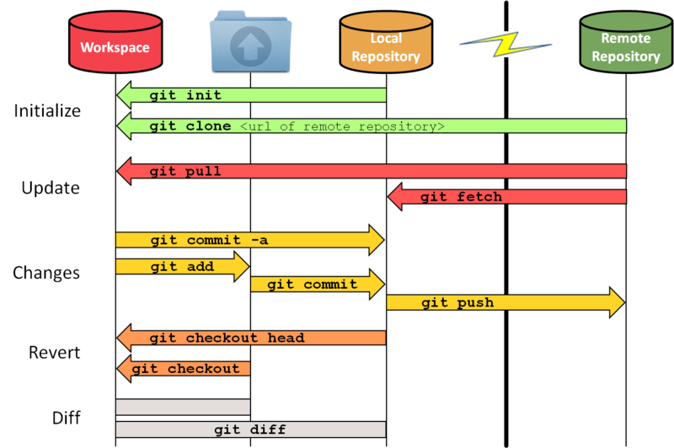

Git Work Flow 3:
